REVERSE ENGINEERING

INTRODUCTION:

I choose a car advertisnment.

A-AUDI

B-BMW

C-FORD

D-TESLA

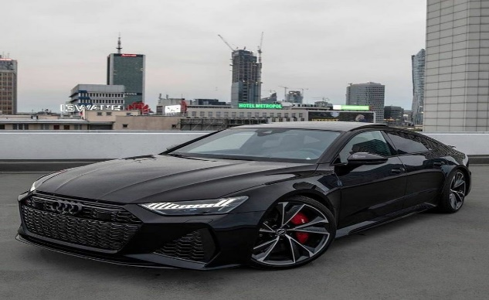A-AUDI B_BMW

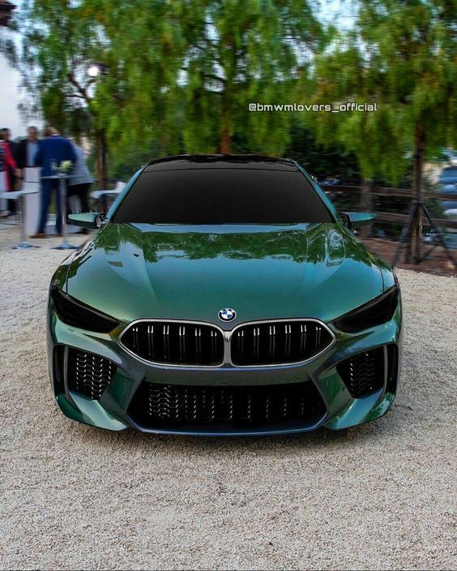

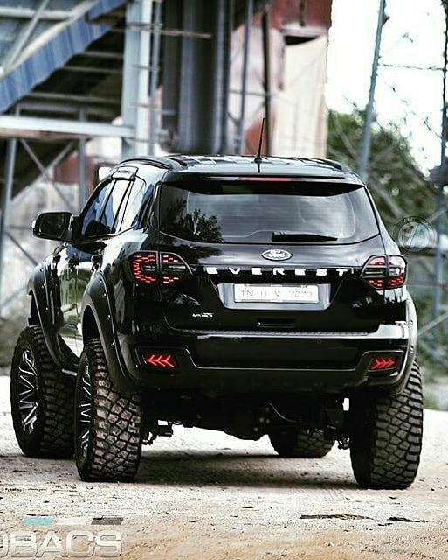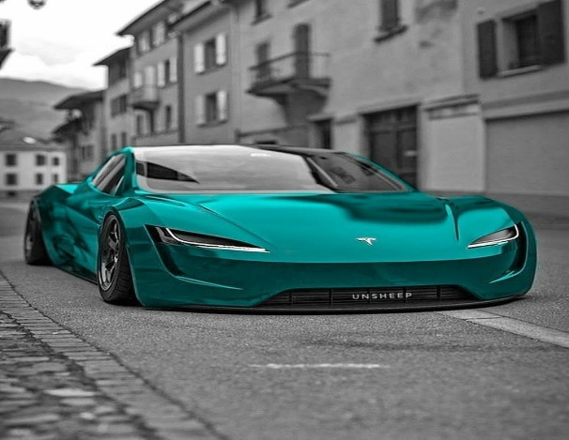

C-FORD D-TESLA

FIRST, I choose 4 types of car in random ways.Based on large family which car is the best??

1.A-Future in attitude,unique,fancy,high cost

2.B-Autonomus drive,Making a driver as best driven

3.C-length and width is comparatively high,Open for new beginning

4.D-Self driving

After compare the 4 car qualities and data C(ford)is best for family to choose…

HYPOTHESIS TESTING

It has 9 steps:

**1.X Value-(0-4) age(18-25)(25-32)(32-45)(45-60)** **CONTINUOUS**

**Y Value-Car sale(Discrete)**

**2.Confidence level:95% Alpha=0.05**

**3.** One way anova

4.mu comparison

5.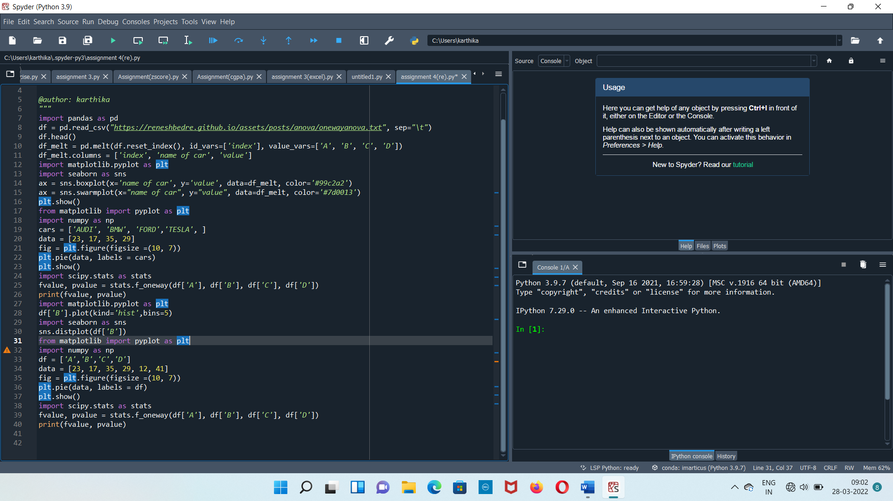

**6.p value=2.62**

**7. p value=2.62 alpha=0.05**

**8.p value is higher than alpha null hypothesis**

**9.Null accepted**